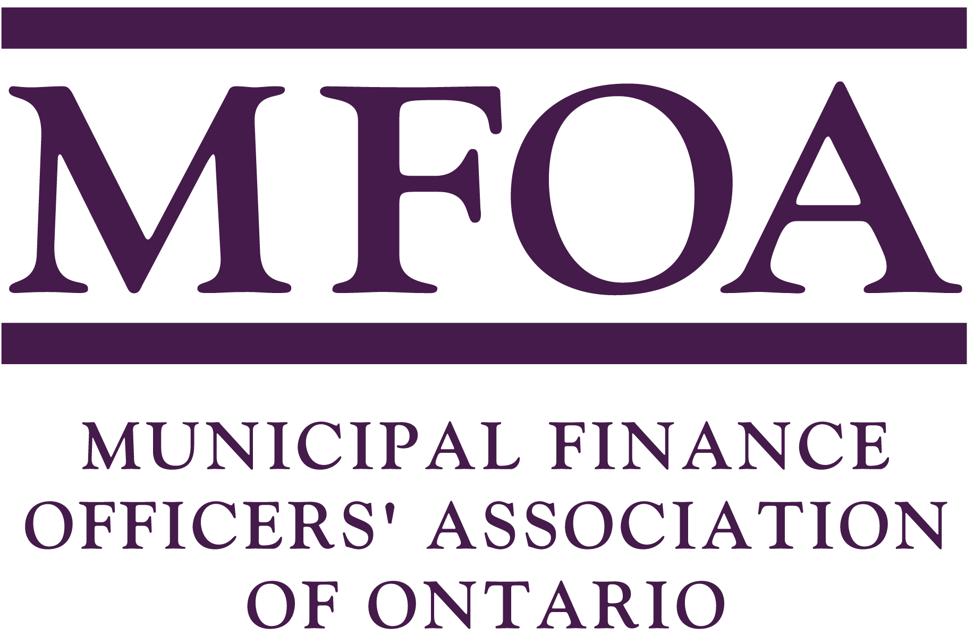
Excellence in Municipal Finance Award

Purpose

This prestigious award is presented at the MFOA Annual Conference in September, to recognize an individual who has made a significant contribution to the field of municipal finance.

Criteria

Potential winners should meet the following criteria:

- Hold a current membership in the Municipal Finance Officers' Association of Ontario or be employed by an MFOA member municipality;

- Practiced in the field of municipal finance for at least 10 years;

- Participated on committees or workshops dealing with topics relevant to municipal finance;

- Become involved in various professional and/or political associations in the Province in Ontario;

- Demonstrated leadership in the field and "Excellence in Municipal Finance".

Award Selection Committee

The MFOA Award Selection Committee will receive nominations and/or make recommendations regarding individuals who qualify for the award. The Committee will select the recipient of the award.

How to Enter

Complete and sign the Entry Form. Where a person wishes to enter more than one eligible candidate, a separate entry form must be completed. There is no entry fee.

Send Entry form to:

Nominating Committee
Municipal Finance Officers' Association
2169 Queen Street East, 2nd Floor
Toronto, Ontario
M4L 1J1

OR

Fax: (416) 362-9226

Deadlines for entries: August 31, 2013

If you have any questions, please do not hesitate to contact Mary Clare Muirhead
by phone at (416) 362-9001 x 224
or by email at maryclare@mfoa.on.ca

Excellence in Municipal Finance Award

Entry Form
(Deadline for entries: August 3, 2013)

Name of Nominee for Award:

Municipality (of Nominee):

Address:

Phone: Fax:

Does the Nominee meet all of the standards for the Award? Please explain.

Why should this Candidate be considered for the Award? Please provide as many details as possible.

Name of Person Submitting the Nomination:

Municipality:

Address:

Phone: Fax: E-mail:

Signature:

