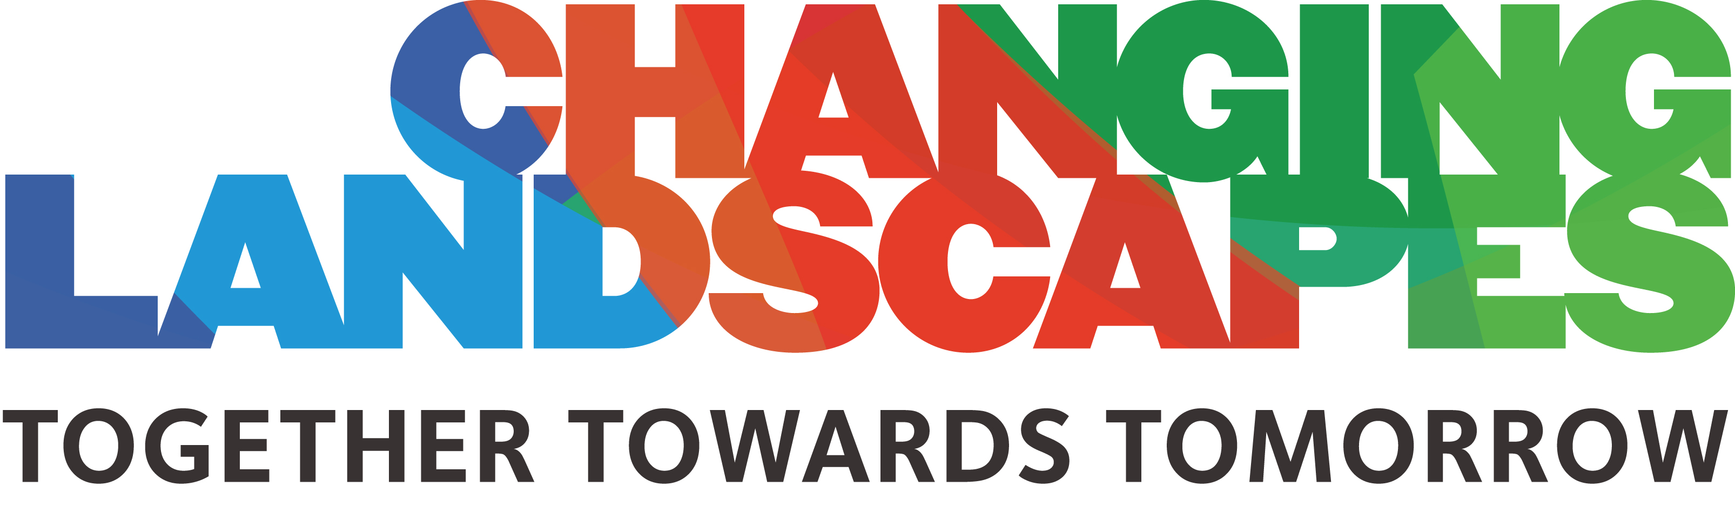

MFOA Conference 2017 - Post-Event Report Template

[Attendee Name]
[Attendee Title and Department]

Summary Evaluation of the MFOA Conference
- Identify specific benefits to your municipality that you learned at the conference
- If you had a goal in mind when attending, recap your goal and what you did to achieve that goal
- Follow up on the specific information you hoped to find at the event in your request to attend, as well as knowledge gained that you hadn’t expected

Knowledge gained at the MFOA Conference
- Refer to your session notes, presentation slides, photos, social media posts, and knowledge shared between attendees
- List new information you’re bringing back, such as: in-depth technical know-how; new development approaches; tips to streamline your work; case studies of success to emulate; or promising new techniques and technologies
- Attach the list of sessions you attended to this report

Information that may benefit my co-workers
- List information that you plan to share with co-workers who could not attend, or technical expertise that you gained that you can teach to your team. Include any useful links for your co-workers such as the presentation slides available on the MFOA website after the conference
- List contacts made that you’re able to pass along to colleagues

People, Companies and Projects of Note
- List a few key contacts you made during the conference, such as peers, presenters/industry experts, vendors
- Include the contact’s name, business, contact information and a brief description of their value to your municipality/organization
- List vendors and products that interest you or might affect your municipality/organization; case studies of special interest, or projects similar to what you are working on

Action Items
- List the top action items to implement, such as: ideas for new approaches to problems; technologies to consider; training your employees or peers; case studies to share; or setting follow-up meetings with vendors or new business contacts

