Convince Your Boss Tips
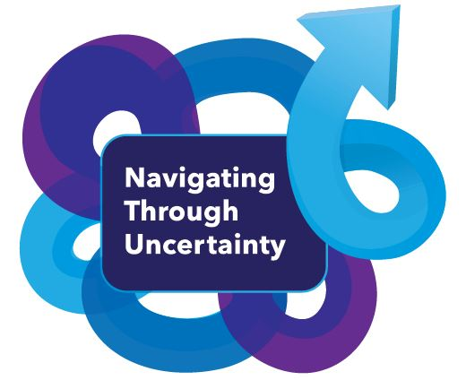

Below is a checklist of helpful tips to demonstrate to your employer the value of attending the MFOA 2019 Annual conference:

Before the Conference
- Focus on what you will specifically bring back to the organization as return for the investment
- Offer to prepare a report or short presentation to your colleagues to share what you have learned. That way, others on your team will get the benefits of your attendance as well
- If you are working to obtain or maintain a professional designation, remind your boss that this is a great way to earn continuing professional development credits
- Be prepared with a plan of coverage while you are attending the conference
- Register by the early bird date to take advantage of discounted rates
- Being an MFOA member offers additional savings on registrations, saving your employer money
- Book your hotel early to receive the discounted conference room block rate
- Preplan your schedule for each day. Review the conference agenda and take time to map out a strategy to select sessions that are most relevant to improve your skills.
- Come prepared – print your session agenda ahead of time

During the Conference
- Register early and take some time to familiarize yourself with the conference venue. You do not want to miss important information or arrive late to a session
- Take notes. Outline your top takeaways at the end or immediately after each session you attend. Turn these statements into actionable statements that describe specific actions you plan to take as a result of attending the training.
- Stay organized and remember what you learned. Between session notes, business cards, and exhibitor handouts, you’ll come away with a wealth of information. Collect your notes and information in a way that will make it easy to access when you return to the office. Keep labels or tags for reminders. Write on the back of people’s business cards to remind yourself of the salient points of your conversation.
- Connect with speakers. Don’t be afraid to ask questions during Q&A or introduce yourself after a presentation.
- Attend the “optional” activities to increase knowledge and networking opportunities.

After the Conference
- Commit to a schedule to de-brief after the conference. Your schedule is bound to get hectic once you return to your home office so it is important to carve out time to get all of the valuable information you have gathered into the hands of your colleagues so you can start sharing ideas and knowledge.
- Schedule time to prepare a post-event report for your supervisor and colleagues, shortly after the conference. That way, the information is still recent and fresh in your memory. Block time on your calendar so it happens.
- Think about the top action items you want to pursue or implement as a result of attending the conference. This may include meetings with your manager or supervisor, training your colleagues or peers, or setting follow-up meetings with vendors or new business contacts
- Download slide decks to help you recall key points and make it easy to share information
- Share the program, speaker handouts and presentation slides with your colleagues. As an attendee, you will have access to presentation slides on the MFOA website after the conference

